
PST manufacturing group
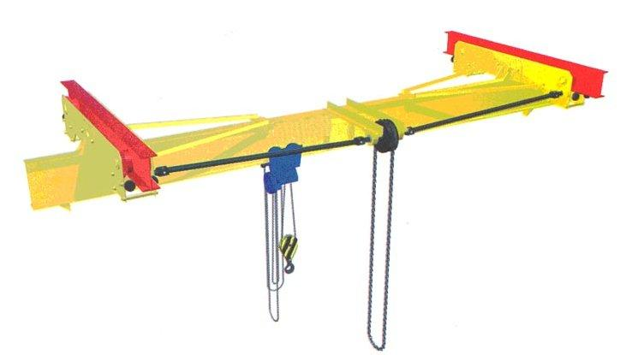
Manually operated single-girder suspension crane

The questionnaire

1. Where and for which purpose the crane is installed:_______________________________________
2. Lifting capacity, t: _________
3. Crane span, м _____________
4. Length of consoles: right, m_________ left, m_________
5. Lifting height, m: ___________
6. Maximal load-lowering height below ground level, m: ___________
7. Lifting load range (load-lifting height + load-lowering height), m ___________
8. Travelling speed, m/s: crane _________; hoist ____________
9. Lifting speed, m/s: _______;
10. Number of I-beam crane-runway according to the GOST (all Union standard) 19425 (obligatory): _________________
11. Height from ground to bottom flange of I-beam crane-runway, m ____________
12. Height from ground to the lowest point of shop girder (overhead cover), m ___________
13. Location of drive sprocket of crane movement:
In the center of span (as in the figure) _____ □;
Inside of span, in _____ m from axis of I-beam of crane rail □
14. Climactic modification and placement category according to the GOST (all Union standard) 15150: У3 ; У2 ; У1 
15. Temperature and humidity in installation zone, °C: min. ________; max. ________at _______%
16. Group of operation mode according to ISO4301/1-86: А1
17. Class of explosion hazard zone (0; 1; 2; 20; 21; 22; no): ________________________
18. Group of explosive mixture (Т1, Т2, Т3, Т4, Т5, Т6; no): _______________________
19. Category of explosive mixture of air with gases or fumes (II, IIA, IIB, IIC; no): _________________________
20. Class of fire-hazardous zone (П-I, П-II, П-IIa, П-III; no): ___________________________
21. Additional information: ______________________________________________________________________

Client’s information
Company’s name, delivery / installation address, contact phone
Your name and surname, position, signature and stamp

Please send signed and stamped filled out questionnaire to our e-mail address:
pst-@mail.ru or mail@pst.zp.ua

