
PST manufacturing group
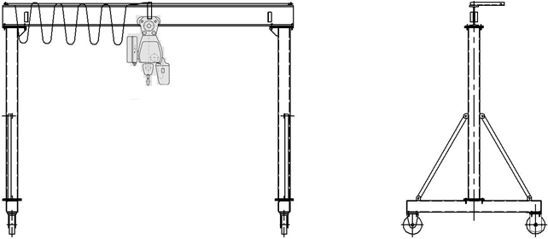
Mobile rehandling facility

The questionnaire

1. Purpose: ___________________________________________________________________________________
- Lifting capacity, t: ___________
- Lifting range, m: ___________
- Span (distance between pillars), m _____________
- Lifting height, m: ___________
- Hoist type: electric □; manual □
- Safe-load limiter: YES □; NO □;
- Lifting speed, m/min.: main _______; auxiliary _________
- Power (voltage, frequency and current type): 380V; 50 Hz; AC. Other _______________________________
- Climactic modification and placement category according to the GOST (all Union standard) 15150: У3  ; У2 ; У1 
- Temperature and humidity in installation zone, °C: min. ________; max. ________at _______%
- Group of operation mode according to the ISO4301/1-86: А2 □ ; А3 □; _____ □
- Control: pendant control station moving with hoist □; radio control □;
Other ______________________________ □
- Class of explosion hazard zone (0; 1; 2; 20; 21; 22; no): ________________________
- Group of explosive mixture (Т1, Т2, Т3, Т4, Т5, Т6; no): _______________________
- Category of explosive mixture of air with gases or fumes (II, IIA, IIB, IIC; no): _______________________
- Class of fire-hazardous zone (П-I, П-II, П-IIa, П-III; no): ___________________________
- Additional information:______________________________________________________________________

Client’s information
Company’s name, delivery / installation address, contact phone
Your name and surname, position, signature and stamp

Please send signed and stamped filled out questionnaire to our e-mail address:
pst-@mail.ru or mail@pst.zp.ua

