
PST manufacturing group
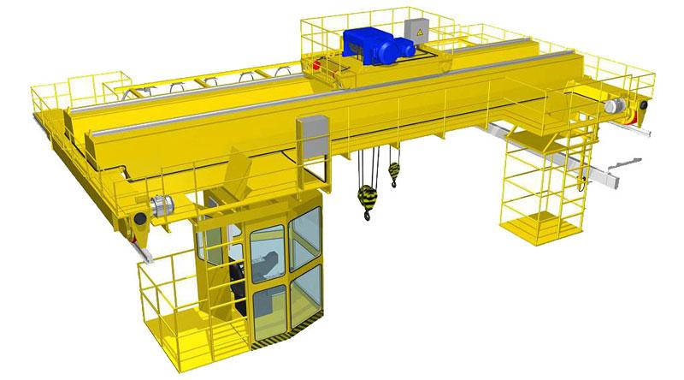
Bridge crane

The questionnaire

1. Where and for which purpose the crane is installed: __________________________________________
2. Load-handling device: hook □; grab □; magnet □; cross beam □; your option ____________________________
3. Safe-load limiter: YES □; NO □
4. Possibility of load weighing YES □; NO □
5. Lifting capacity, t: main lifting ___________; auxiliary lifting ________
6. Lifting height, m: main hook ___________; auxiliary hook ________
7. Maximal load-lowering height below ground level, m: main hook ___________; auxiliary hook ________
8. Lifting load range (load-lifting height + load-lowering height), m ___________
9. Crane span, м _____________
10. Travelling speed, m/s: crane _________; trolley ____________
11. Lifting speed, m/s: main _______; auxiliary _________
12. Variable-frequency control: YES  for gear__________________________; NO 
13. Type and size of crane rail (obligatory): _________________
14. Height from ground to the level of rail top, m ____________
15. Height from ground to the lowest point of shop girder (overhead cover), m ___________
16. Current feed to crane: flexible cable □; trolley □
17. Current feed to trolley: flexible cable □; trolley □
18. Power: ________________380V; 50 Hz; your option _______________________________
19. Climactic modification and placement category according to the GOST (all Union standard) 15150: У3 ; У2 ; У1 
20. Temperature and humidity in installation zone, °C: min. __________; max. ________at______%
21. Group of operation mode according to the ISO4301/1-86: ______________
22. Control: from control station □ connection cable length, m_________; from cabin □; radio control □
Pendent control station moving with the crane □;
Pendent control station fixed on the longitudinal beam □; other ______________________________ □
23. Control cabin: closed fixed □; closed moving with trolley □;
Your option _______________________________________________________________________________________
24. Air-conditioner in the cabin: YES □; NO□
25. Class of explosion hazard zone (0; 1; 2; 20; 21; 22; no): ________________________
26. Group of explosive mixture (Т1, Т2, Т3, Т4, Т5, Т6; no): _______________________
27. Category of explosive mixture of air with gases or fumes (II, IIA, IIB, IIC; no): _____________
28. Class of fire-hazardous zone (П-I, П-II, П-IIa, П-III; no): _________________
29. Additional information: ______________________________________________________________________

Client’s information
Company’s name, delivery / installation address, contact phone
Your name and surname, position, signature and stamp

Please send signed and stamped filled out questionnaire to our e-mail address:
pst-@mail.ru or mail@pst.zp.ua

