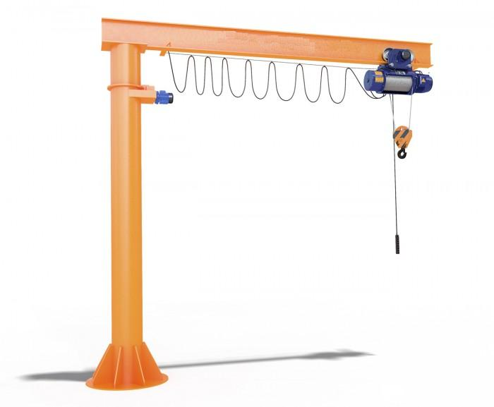

PST manufacturing group
Electric jib crane

The questionnaire

1. Where and for which purpose the crane is installed: ________________________________________

2. Lifting capacity, t: ___________
3. Distance from the pillar’s axis to the hook (boom reach): minimal, m _______ maximal, m ______
4. Maximal distance from the pillar’s axis to the end of cranes lever, m ______
5. Lifting height, m: ___________
6. Maximal load-lowering height below ground level, m: ___________
7. Lifting load range (load-lifting height + load-lowering height), m ___________
8. Safe-load limiter: YES □; NO □;
9. Hoist travelling speed, m/s: ________
10. Lifting speed, m/min.: main _______; auxiliary _________
11. Lever’s turn: manual, with chain on the lever’s end □; electric □;
12. Lever’s turning speed (if the electric drive of lever’s turn is require), r/min: 1,02□; ______□;
13. Lever’s angle of turning, degree: 350 □; ______□;
14. Variable-frequency control: YES  for gear__________________________; NO 
15. Foundation bolt holes:
______quantity of holes with diameter ______mm, evenly located on diameter _____mm
16. Height from ground to crane’s top, m, no more than____________
17. Height from ground to the lowest point of shop’s girder (overhead cover), m ___________
18. Current feed to hoist: flexible cable □; other _______________________________________□;
19. Power (voltage, frequency and current type): 380V; 50 Hz; AC. Other _______________________________
20. Climactic modification and placement category according to the GOST (all Union standard) 15150: У3  ; У2 ; У1 
21. Temperature and humidity in installation zone, °C: min. ________; max. ________at _______%
22. Group of operation mode according to the ISO4301/1-86: А2 □ ; А3 □; А4 □; _____ □
23. Control: from control station □ connection cable length, m_________; radio control □
Pendant control station moving with hoist □; Control station fixed on the pillar □
24. Class of explosion hazard zone (0; 1; 2; 20; 21; 22; no): ________________________
25. Group of explosive mixture (Т1, Т2, Т3, Т4, Т5, Т6; no): _______________________
26. Category of explosive mixture of air with gases or fumes (II, IIA, IIB, IIC; no): _________________________
27. Class of fire-hazardous zone (П-I, П-II, П-IIa, П-III; no): ___________________________
28. Additional information:______________________________________________________________________

Client’s information
Company’s name, delivery / installation address, contact phone
Your name and surname, position, signature and stamp

Please send signed and stamped filled out questionnaire to our e-mail address:
pst-@mail.ru or mail@pst.zp.ua

