
PST manufacturing group

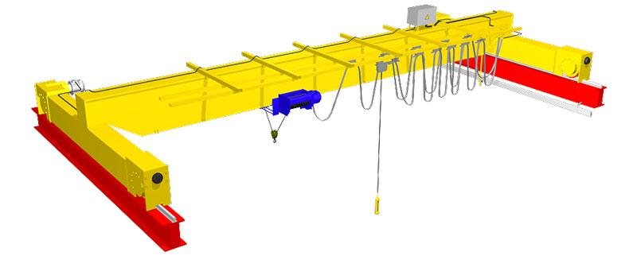
Electric single-girder overhead crane

The questionnaire

- Where and for which purpose the crane is installed:____________________________________________
- Lifting capacity, t: ___________
3. Crane span, м _____________
4. Lifting height, m: ___________
5. Maximal load-lowering height below ground level, m: ___________
6. Lifting load range (load-lifting height + load-lowering height), m ___________
7. Safe-load limiter: YES □; NO □;
8. Travelling speed, m/s: crane _________; hoist ____________
9. Lifting speed, m/min: main _______; auxiliary _________
10. Variable-frequency control: YES  for gear__________________________; NO 
11. Type of crane rail or size of square (obligatory): _________________
12. Height from ground to the level of rail top, m ____________
13. Height from ground to the lowest point of shop girder (overhead cover), m ___________
14. Current feed to crane: flexible cable □; trolley □
15. Current feed to hoist: flexible cable □; trolley □
16. Power (voltage, frequency and current type): 380V; 50 Hz; AC. Other _______________________________
17. Climatic modification and placement category according to the GOST (all Union standard) 15150: У3 ; У2 ; У1 
18. Temperature and humidity in crane installation zone, °C: min. ________; max. ________at _______%
19. Group of operation mode according to the ISO4301/1-86: А2 □; А3 □; _____ □
20. Control: from control station □ connection cable length, m_________; radio control □
Pendent control station moving with the hoist □;
Pendent control station fixed on the longitudinal beam □; other ______________________________ □
21. Class of explosion hazard zone (0; 1; 2; 20; 21; 22; no): ________________________
22. Group of explosive mixture (Т1, Т2, Т3, Т4, Т5, Т6; no): _______________________
23. Category of explosive mixture of air with gases or fumes (II, IIA, IIB, IIC; no): _________________________
24. Class of fire-hazardous zone (П-I, П-II, П-IIa, П-III; no): ___________________________
25. Additional information: ______________________________________________________________________

Client’s information
Company’s name, delivery / installation address, contact phone
Your name and surname, position, signature and stamp

Please send signed and stamped filled out questionnaire to our e-mail address:
pst-@mail.ru or mail@pst.zp.ua

