
PST manufacturing group
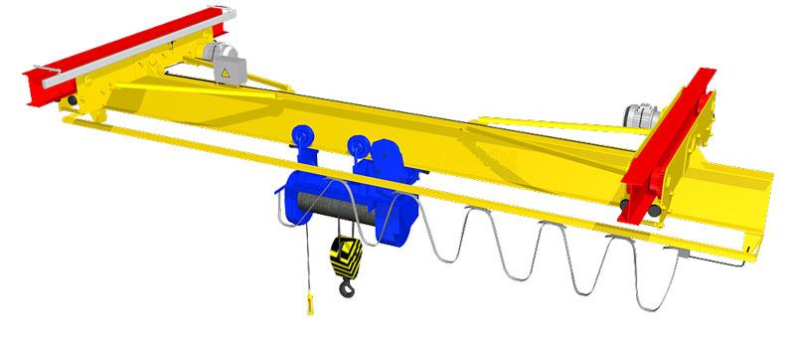
Electric single-girder suspension crane

The questionnaire

1. Where and for which purpose the crane is installed: ________________________________________
2. Lifting capacity, t: _________
3. Crane span, m _____________
4. Length of consoles: right, m_________ left, m_________
5. Lifting height, m: ___________
6. Maximal load-lowering height below ground level, m: ___________
7. Lifting load range (load-lifting height + load-lowering height), m ___________
8. Safe-load limiter: YES □; NO □
9. Travelling speed, m/s: crane _________; hoist ____________
10. Lifting speed, m/s: main _______; auxiliary _________
11. Variable-frequency control: YES  for gear__________________________; NO 
12. Number of I-beam crane-runway according to the GOST (all Union standard) 19425 (obligatory): _________________
13. Height from ground to bottom flange of I-beam crane-runway, m ____________
14. Height from ground to the lowest point of shop girder (overhead cover), m ___________
15. Current feed to crane: flexible cable □; trolley □
16. Current feed to hoist: flexible cable □; cable trolleys on monorail □
17. Power (voltage, frequency and current type): 380V; 50 Hz; AC. Other _______________________________
18. Climactic modification and placement category according to the GOST (all Union standard) 15150: У3  ; У2 ; У1 
19. Temperature and humidity in installation zone, °C: min. ________; max. ________at _______%
20. Group of operation mode according to ISO4301/1-86: А2 □ ; А3 □; _____ □
21. Control: from control station □ connection cable length, m_________; radio control □;
Pendent control station moving with the hoist □;
Pendent control station fixed on the longitudinal beam □; other ______________________________ □;
22. Class of explosion hazard zone (0; 1; 2; 20; 21; 22; no): ________________________
23. Group of explosive mixture (Т1, Т2, Т3, Т4, Т5, Т6; no): _______________________
24. Category of explosive mixture of air with gases or fumes (II, IIA, IIB, IIC; no): _________________________
25. Class of fire-hazardous zone (П-I, П-II, П-IIa, П-III; no): ___________________________
26. Additional information:______________________________________________________________________

Client’s information
Company’s name, delivery / installation address, contact phone
Your name and surname, position, signature and stamp

Please send signed and stamped filled out questionnaire to our e-mail address:
pst-@mail.ru or mail@pst.zp.ua

