
PST manufacturing group

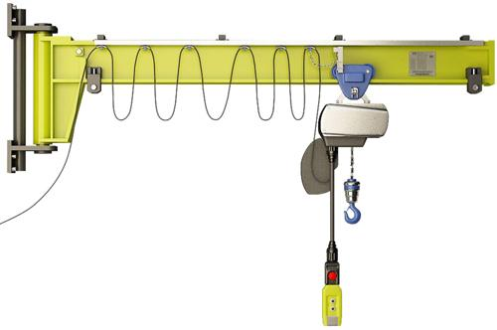
Electric wall-type jib crane

The questionnaire

1. Where and for which purpose the crane is installed:_________________________________________
2. Lifting capacity, t: ___________
3. Distance from the rotation axis to the hook, boom reach: minimal, m _______ maximal, m ______
4. Maximal distance from the rotation axis to the end of cranes lever, m ______
5. Distance from wall to the rotation axis, m
6. Lifting height, m: ___________
7. Maximal load-lowering height below ground level, m: ___________
8. Lifting load range (load-lifting height + load-lowering height), m ___________
9. Safe-load limiter: YES □; NO □;
10. Hoist travelling speed, m/s: ________
11. Lifting speed, m/min.: main _______; auxiliary _________
12. Lever turn: manual, with chain on lever’s end □; manual with turning gear □;
13. Lever angle of turning, degree: 135 □; ______□;
14. Variable-frequency control: YES  for gear__________________________; NO 
15. Mounting bolt holes to wall:
______ quantity of holes with diameter ______mm.
16. Distance between supports along the axis of bolts attaching points, mm ___________
17. Height from ground to crane top, m, no more than____________
17. Height from ground to the lowest point of shop girder (overhead cover), m ___________
18. Current feed to hoist: flexible cable
19. Power (voltage, frequency and current type): 380V; 50 Hz; AC. Other _______________________________
20. Climactic modification and placement category according to the GOST (all Union standard) 15150: У3 ; У2 ; У1 
21. Temperature and humidity in installation zone, °C: min. ________; max. ________at _______%
22. Group of operation mode according to the ISO4301/1-86: А2 □; А3 □; А4 □; _____ □
23. Control: from control panel □ connection cable length, m_________; radio control □
Pendant control panel moving with hoist □; Control panel fixed on pillar □
24. Class of explosion hazard zone (0; 1; 2; 20; 21; 22; no): ________________________
25. Group of explosive mixture (Т1, Т2, Т3, Т4, Т5, Т6; no): _______________________
26. Category of explosive mixture of air with gases or fumes (II, IIA, IIB, IIC; no): _________________________
27. Class of fire-hazardous zone (П-I, П-II, П-IIa, П-III; no): ___________________________
28. Additional information: ______________________________________________________________________

Client’s information
Company’s name, delivery / installation address, contact phone
Your name and surname, position, signature and stamp

Please send signed and stamped filled out questionnaire to our e-mail address:
pst-@mail.ru or mail@pst.zp.ua

