
PST manufacturing group

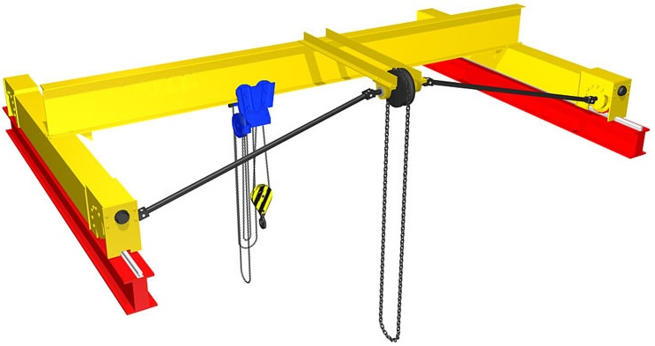
Manually operated single-girder overhead crane

The questionnaire

1. Where and for which purpose the crane is installed:_________________________________________________
2. Lifting capacity, t: ___________
3. Crane span, м _____________
4. Lifting height, m: ___________
5. Maximal load-lowering height below ground level, m: ___________
6. Lifting load range (load-lifting height + load-lowering height), m ___________
7. Travelling speed, m/s : crane _________ ; hoist ____________
8. Lifting speed, m/min.: _______
9. Type of crane rail or size of square (obligatory): _________________
10. Height from ground to the level of rail top, m ____________
11. Height from ground to the lowest point of shop girder (overhead cover), m ___________
12. Location of drive sprocket of crane movement:
In the center of span (as on the picture) _____ □;
inside of span, in _____ m from axis of I-beam of crane rail □
13. Climatic modification and placement category according to the GOST (all Union standard) 15150: У3  ; У2 ; У1 
14. Temperature and humidity in installation zone, °C: min. ________; max. ________at _______%
15. Group of operation mode according to ISO4301/1-86: А1
16. Class of explosion hazard zone (0; 1; 2; 20; 21; 22; no): ________________________
17. Group of explosive mixture (Т1, Т2, Т3, Т4, Т5, Т6; no): _______________________
18. Category of explosive mixture of air with gases or fumes (II, IIA, IIB, IIC; no): _________________________
19. Class of fire-hazardous zone (П-I, П-II, П-IIa, П-III; no): ___________________________
20. Additional information:______________________________________________________________________

Client’s information
Company’s name, delivery / installation address, contact phone
Your name and surname, position, signature and stamp

Please send signed and stamped filled out questionnaire to our e-mail address:
pst-@mail.ru or mail@pst.zp.ua

